MOVIE TABLE

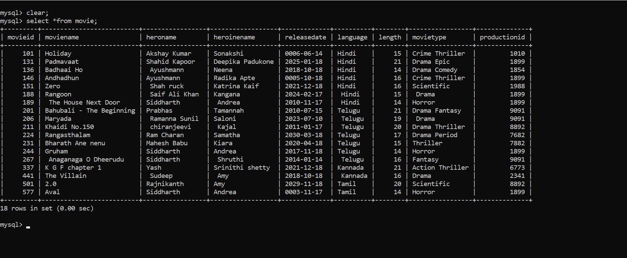

PRODUCTION TABLE

1. Display the name of movies, movie type is starts with Drama.

2) Display the movies acted by actor Ayshmann.

3. Display the count of movies, having length above 18.

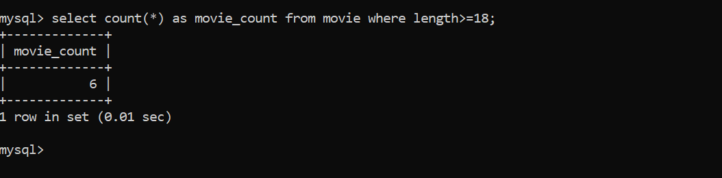

4)Display the movie having minimum length.

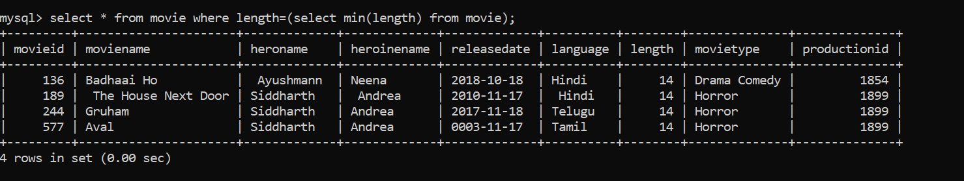

5)Display all the details of movie, the language that first name starts with ‘T’

6. Display the movie name, hero name, heroine name whose having

maximum length.

7. Display the movie name, hero name, heroine name the movie released

after 15 march 2018.

8. Display the count of thriller movies.

9. Display the count of movies whose released before 15 march 2018.

10. Display the release date of the movie name ‘Zero’

